Please answer all questions as a group. Please distribute questions amongst your group as evenly as reasonably possible. Compile your answers in one final document and attach this to the discussion group posting for week 2. This will be available later today.
This is due at 10:00PM, Tuesday January 22. When you submit your final document be sure to include the person’s name who answered it beside each question.

Use the class notes and internet to find your answers.

Section 1: Review Questions
1. In 4 lines or less (or lose marks) define each of the following:
- Unary relation (Give an example and show an ERD diagram)
- Schema
- Data definition language

2. The next series of questions use the following tables:
TRUCK
TNUM | BASENUM | TYPENUM | TMILES | TBOUGHT | TSERIAL
1001 | 501 | 1 | 5900.2 | 11/08/90 | aa-125
1002 | 502 | 2 | 64523.9 | 11/08/90 | ac-213
1003 | 501 | 2 | 32116.0 | 09/29/91 | ac-215
1004 |  | 2 | 3256.9 | 01/14/92 | ac-315

BASE
BASENUM | BASECITY | BASESTATE | BASEPHON | BASEMGR
501 | Dallas | Tx | 893-9870 | J.Jones
502 | New York | NY | 234-7689 | K.Lee

TYPE
TYPENUM | TYPEDESC
1 | single box,double axle
2 | tandem trailer,single axle

- List the primary and foreign keys for each table.

TRUCK: TNUM (PK), BASENUM (FK), TYPENUM (FK)
BASE: BASENUM (PK)
TYPE: TYPENUM (PK)
(Steffen)

- Do the tables exhibit entity integrity? Explain why.

Yes, the tables exhibit entity integrity because the primary keys for each table are not null.
(Steffen)

- Draw the ERD to show the relationship and cardinality for these tables.

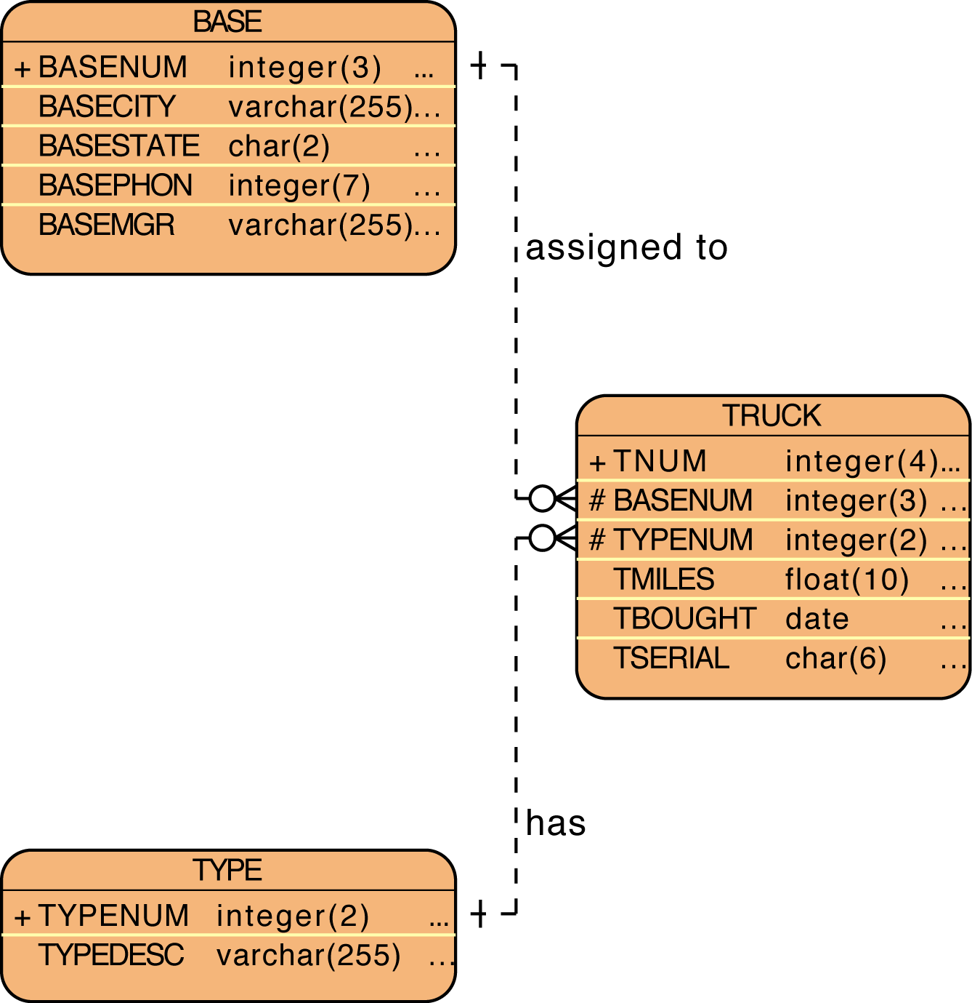
(Steffen)

- Does these tables exhibit referential integrity? Explain why.

The tables exhibit referential integrity because each foreign key that exists in the TRUCK table references the primary key of both the TYPE and BASE tables.
(Steffen)

- Does these tables exhibit entity integrity? Explain why.

Yes, the tables exhibit entity integrity because the primary keys for each table are not null.
(Steffen)

3. Given the following diagram, what are the primary, foreign, and candidate keys?

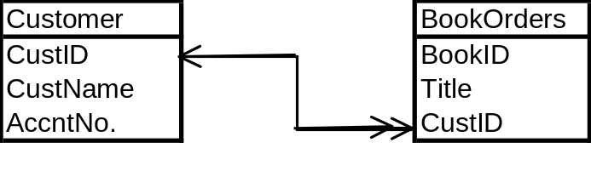

4.
a. Create an ERD to describe the relationship between an order that has multiple products. Each product only appears once on the order. However, different manufacturers may supply the same product. Focus on the order, product, and manufacturer entities and be aware of the need for bridge entities. Do not include customer entities or pricing information or shipper information. Keep this relatively simple.

b. List the business rules for the ERD.

c. Invent four different constraints for the data model that are not shown in the ERD or current business rules.

5. Draw an ERD for the following tables:
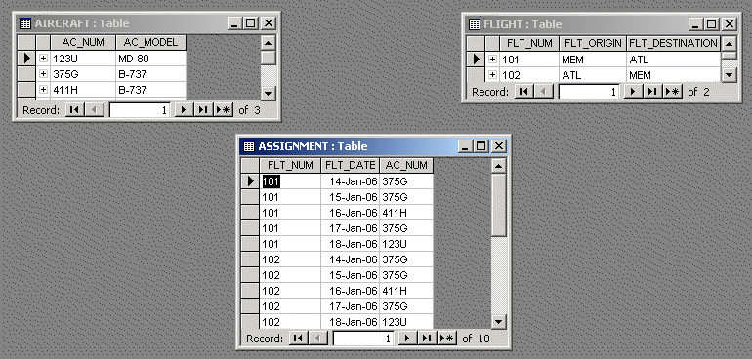

Section 2: Prep Questions for next class (also due Tuesday January 22)
6. Answer each question in 4 lines or less or lose marks.
a) What is a weak entity? Give an example.
b) What is a strong entity? Given an example.
c) What is a weak relationship? Give an example.
d) What is a strong relationship? Give an example.

7. Answer each question in 4 lines or less or lose marks.
a) What is a derived attribute?
b) What are two advantages of storing a derived attribute?
c) What are two advantages of not storing a derived attribute?

8. Draw the following ERD using UML notation:

